INTERNSHIP APPLICATION

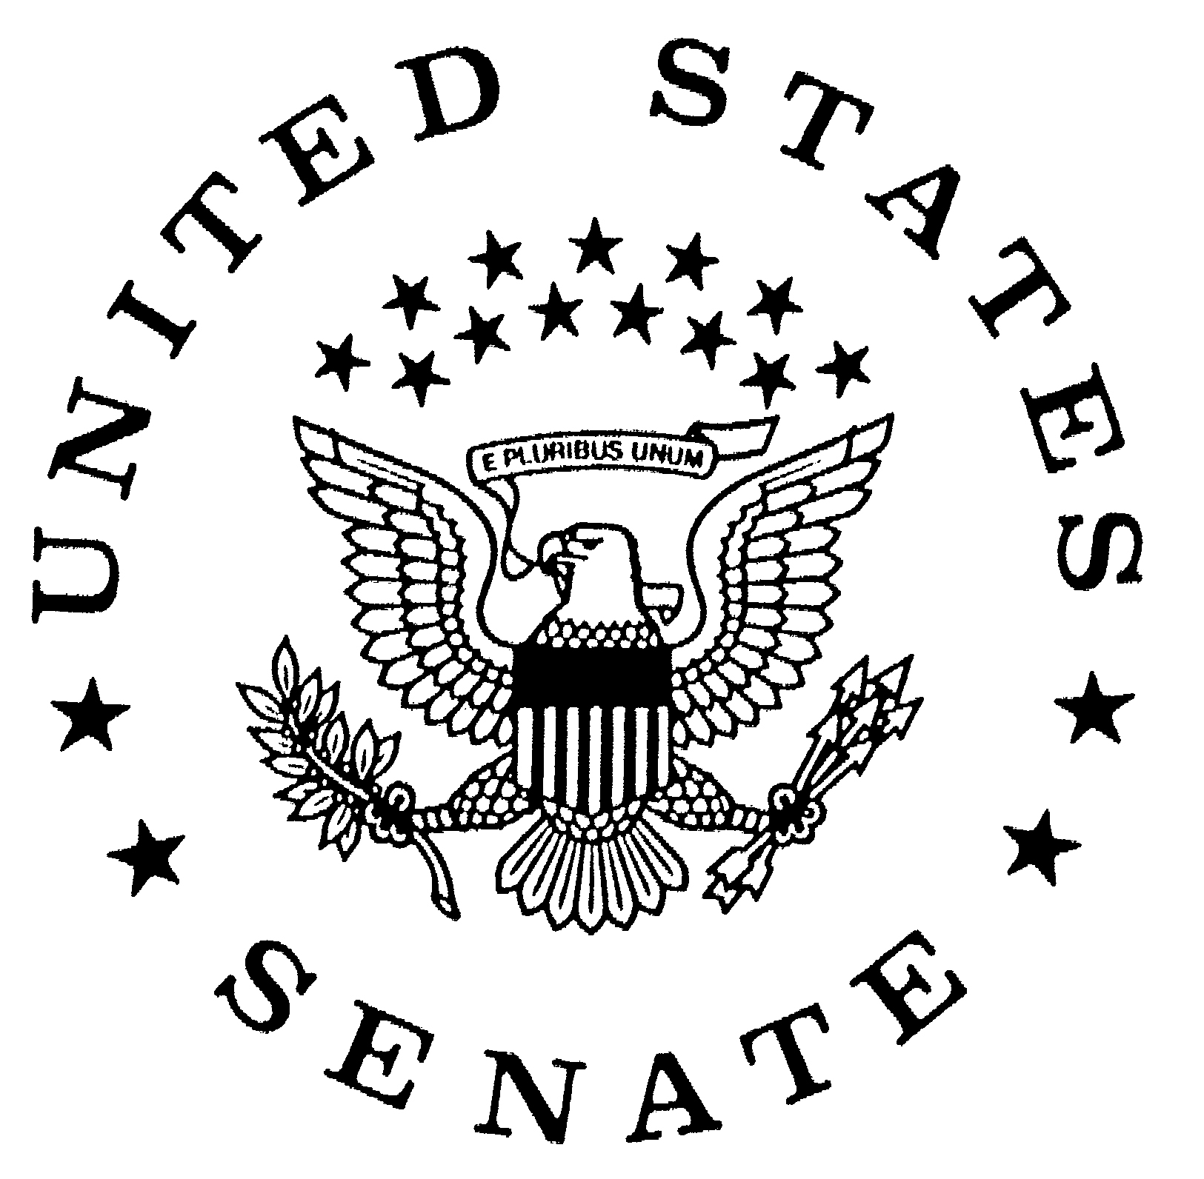

Office of U.S. Senator Richard J. Durbin
Illinois

INTERNSHIP OPPORTUNITIES

Thank you very much for your interest in the internship opportunities available in the Office of U.S. Senator Dick Durbin.

Our internship program is unique in many ways. We try to match an intern’s skills with the needs of our office. In the time you spend here, you will experience much of what we do on a day-to-day basis. You will assist staff in matters involving federal agencies, work with our press and scheduling offices and help to manage our front desk. Not every assignment will be fun or glamorous, but we hope this experience will be useful in your course of study or as you choose your own career path.

Our interns are an integral and appreciated part of our office. We work hard to ensure that interns leave here with a working knowledge of government affairs. We also realize it is important for participants to have accomplished individual goals. There are many fun and interesting aspects to the program and you will have the opportunity to explore your own interests.

At times, you will find yourself immersed in political debate and discussion, and you will be challenged to think and work independently. Our staff is very close and you will inevitably get to know many of the staff members well. As in any work environment, interns are expected to work hard and act professionally at all times. We are excited to have you with us and hope you take advantage of this great opportunity.

APPLICATION PROCESS

Please complete all sections of the application. All requested materials must be submitted together.

To be considered for an internship, the application must include:

- Internship Application Form
- Current Resume
- Cover letter describing why you would like to intern in Senator Durbin’s Office
- Name, title, and contact information for an academic or professional reference (reference must be a supervisor, professor, or mentor; a letter of recommendation is not required)

You must submit these materials to each office location in which you are applying to intern.
SESSION DATES AND APPLICATION DEADLINES

Washington, D.C. Office

SESSION NAME | SESSION DATES | APPLICATION DEADLINES
Fall 2017 | September 5, 2017 – December 21, 2017 | Undergraduate Students:  July 6, 2017  Law/Graduate Students:  January 5,2017
Spring 2018 | January 8, 2018 – May 11, 2018 | Undergraduate Students:  October 5, 2017  Law/Graduate Students:  January 5,2017
Summer  Session I 2018 | May 9, 2018 – July 6, 2018 | Undergraduate Students:  February 1, 2018  Law/Graduate Students:  January 5,2017
Summer  Session II 2018 | July 2, 2018 – August 31, 2018 | Undergraduate Students:  February 1, 2018  Law/Graduate Students:  January 5,2017

Illinois State Offices

Chicago | Springfield | Carbondale | Rock Island

SESSION NAME | SESSION DATES | APPLICATION DEADLINES
Fall 2016 | September 6, 2016 – December 21, 2016 | July 29, 2016
Spring 2017 | January 9, 2017 – May 12, 2017 | November 4, 2016
Summer  Session I 2017 | May 10, 2017 – July 7, 2017 | February 24, 2017
Summer  Session II 2017 | July 5, 2017 – August 25, 2017 | February 24, 2017

FUNDING

This internship is unpaid.

COMPLETED APPLICATIONS

Please submit your completed application and materials to the office in which you would like to intern. If you are submitting your materials via e-mail, please include in the subject line the office to which you are applying.

You must submit the completed application to each office location in which you are applying to intern.

Contact information is as below:

Washington, D.C. Office
Ms. Mallory Carter
Mr. Chad Phillips
Intern Coordinators
Office of U.S. Senator Dick Durbin
711 Hart Senate Office Building
Washington, DC 20510
phone: (202) 224-2152
fax: (202) 228-0400
internships@durbin.senate.gov

Chicago Office
Ms. Alicia Johnson
Intern Coordinator
Office of U.S. Senator Dick Durbin
230 S. Dearborn Street, Suite 3892
Chicago, IL 60604
phone: (312) 353-4952
fax: (312) 353-0150
internships@durbin.senate.gov

Springfield Office
Ms. Stacie Barton Hackler
Intern Coordinator
Office of U.S. Senator Dick Durbin
525 S. 8th Street
Springfield, IL 62703
phone: (217) 492-4062
fax: (217) 492-4382
internships@durbin.senate.gov

Carbondale Office
Ms. Brandi Bradley
Intern Coordinator
Office of U.S. Senator Dick Durbin
250 W. Cherry Street, Suite 115-D
Carbondale, IL 62901
phone: (618) 351-1122
fax: (618) 351-1124
internships@durbin.senate.gov

Rock Island Office
Ms. Jill Dykhoff
Intern Coordinator
Office of U.S. Senator Dick Durbin
1504 Third Avenue, Suite 227
Rock Island, IL 61201
phone: (309) 786-5173
fax: (309) 786-5404
internships@durbin.senate.gov

PLEASE NOTE:
Due to ongoing delays in postal mail to federal buildings,
especially in Washington, D.C., it is preferred that applications
are submitted via e-mail as a single pdf.

Personal Information
Name:_____________________________________________ |  | Date of Birth:________________
Permanent Address:___________________________________ |  | Phone:______________________
______________________________________________________________________________________
Current Address:_____________________________________ |  | Phone:______________________
______________________________________________________________________________________
Are you a registered voter? Yes__________ No__________ If yes, in which state?___________
Relevant experience (e.g. campaign, politics, government):______________________________
______________________________________________________________________________________
Areas of Interest: _____________________________________________________________________
______________________________________________________________________________________
Extracurricular activities: _____________________________________________________________
______________________________________________________________________________________
How did you hear about this internship program? _____________________________________
Education
High School:________________________________________ |  | Graduation Date:_____________
High School City and State: ___________________________________________________________
College:____________________________________________ |  | Graduation Date:_____________
• Major/Minor:______________________________________ |  | GPA:_________________________
Graduate/Law School:_________________________________ |  | Graduation Date:_____________
• Major/Minor:______________________________________ | GPA:_________________________
Languages spoken (indicate degree of fluency):_________________________________________

Will high school/college credit be earned through this internship? |  | Yes:_____ No:______
If yes, please complete the following:
Professor:_______________________________ | Phone Number:___________________________
Course Name:____________________________ | Total Credits Earned:______________________

As internships in this office are unpaid, do you plan on receiving an outside stipend or scholarship for your internship? ______________________________________________

If yes, please list your possible sponsor: _______________________________________

Office and session you are applying for:
(If you are applying for more than one session or more than one office*, please number your choices in order of preference.)
 | Fall | Spring | Summer I | Summer II
Washington, D.C.: | _____ | _____ | _____ | _____
Chicago: | _____ | _____ | _____ | _____
Springfield: | _____ | _____ | _____ | _____
Carbondale: | _____ | _____ | _____ | _____
Rock Island: | _____ | _____ | _____ | _____
Dates Available: ____/____/____ through ____/____/____
*NOTE: You must submit a full application to each office marked above.
Hours Available:
Monday: | ________ to ________ |  | Thursday: | ________ to ________
Tuesday: | ________ to ________ |  | Friday: | ________ to ________
Wednesday: | ________ to ________

Certification

My statements on this form and on all of my application materials are true to the best of my knowledge and belief. I understand that knowingly making false statements will lead to the rejection of my application or removal from the internship program.

Signature: __________________________________________ Date: __________________

